Bluetooth Headsets Enjoy Talking on Mobile
For all the mobile phone users, a Bluetooth headset is a boon. This device operates by using radio waves rather than wires or other means of connection. It helps you in keeping your hands free while driving or walking. Such benefits make Bluetooth headsets very useful for all the Smartphone users.
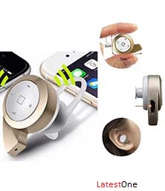
Many impressive Bluetooth devices are developed in recent few years. People are widely using those devices because the maximum of them reduce troubles people face when using their smartphones. Bluetooth has completely eliminated demand of wire and thus the mobile users have got improved devices to perform necessary operations of the Smartphone.
The working way of Bluetooth Headsets :
Before a few years, people used to apply wired headphones to listen music and talk freely. Headphone was quite useful invention because it has eliminated need of catching mobile phone near the ear to talk. However, still it was a problematic device because caring headphone everywhere was a difficult task because of its wires. The Bluetooth headset has came out as a great alternative to normal headphones. It gets connected to the Smartphone via Bluetooth technology. In other words, the Bluetooth device uses low range radio waves to connect two devices and therefore there is no need of using annoying wires for connection.
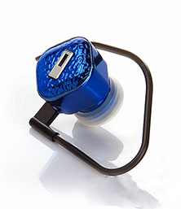
Bluetooth headsets can work effectively, if the user is using this device into the limited range. Off-course, there is no need to pick out Smartphone again and again, whenever you want to receive the call. Just press the multi functioning button and you have done. All the mobile phone manufacturing companies are providing phones with Bluetooth feature. It means, every mobile phone user can get a Bluetooth Headset and connect it and use it for better convenience. Things become quite easier for the users, when they use Bluetooth headsets instead of headphones. They talk freely and safely, whether they are at home or in the car.
Who must use Bluetooth Headsets ?
A Bluetooth headset is a great device for those, who more frequently use their mobile phone to make and receive call. You must buy it, if you are a businessman and you need to make at least 50 calls per day. Making such large calls every day without using a headphone or Bluetooth headset would be risky for your health. All the mobile phones and Smartphones release RF radiation. It can be life-threatening if a user frequently comes in contact with that. People should know that and they must apply the ways of reducing contact with harmful RF radiations.
A Bluetooth headset which is manufactured by a well-reputable brand releases negligible amount of RF radiation that can’t affect your health. It means, you will be safe whether you make limited calls or a lot of calls in a day. The Bluetooth headsets are affordable devices for all. Many electronic device manufacturing companies produce it and sell it on quite cost-effective prices. You can also buy it online, if you want to save money and time. Check available options in this Bluetooth device and get it now to enjoy all the benefits offered by Bluetooth Headsets.
For more visit
http://www.latestone.com/

